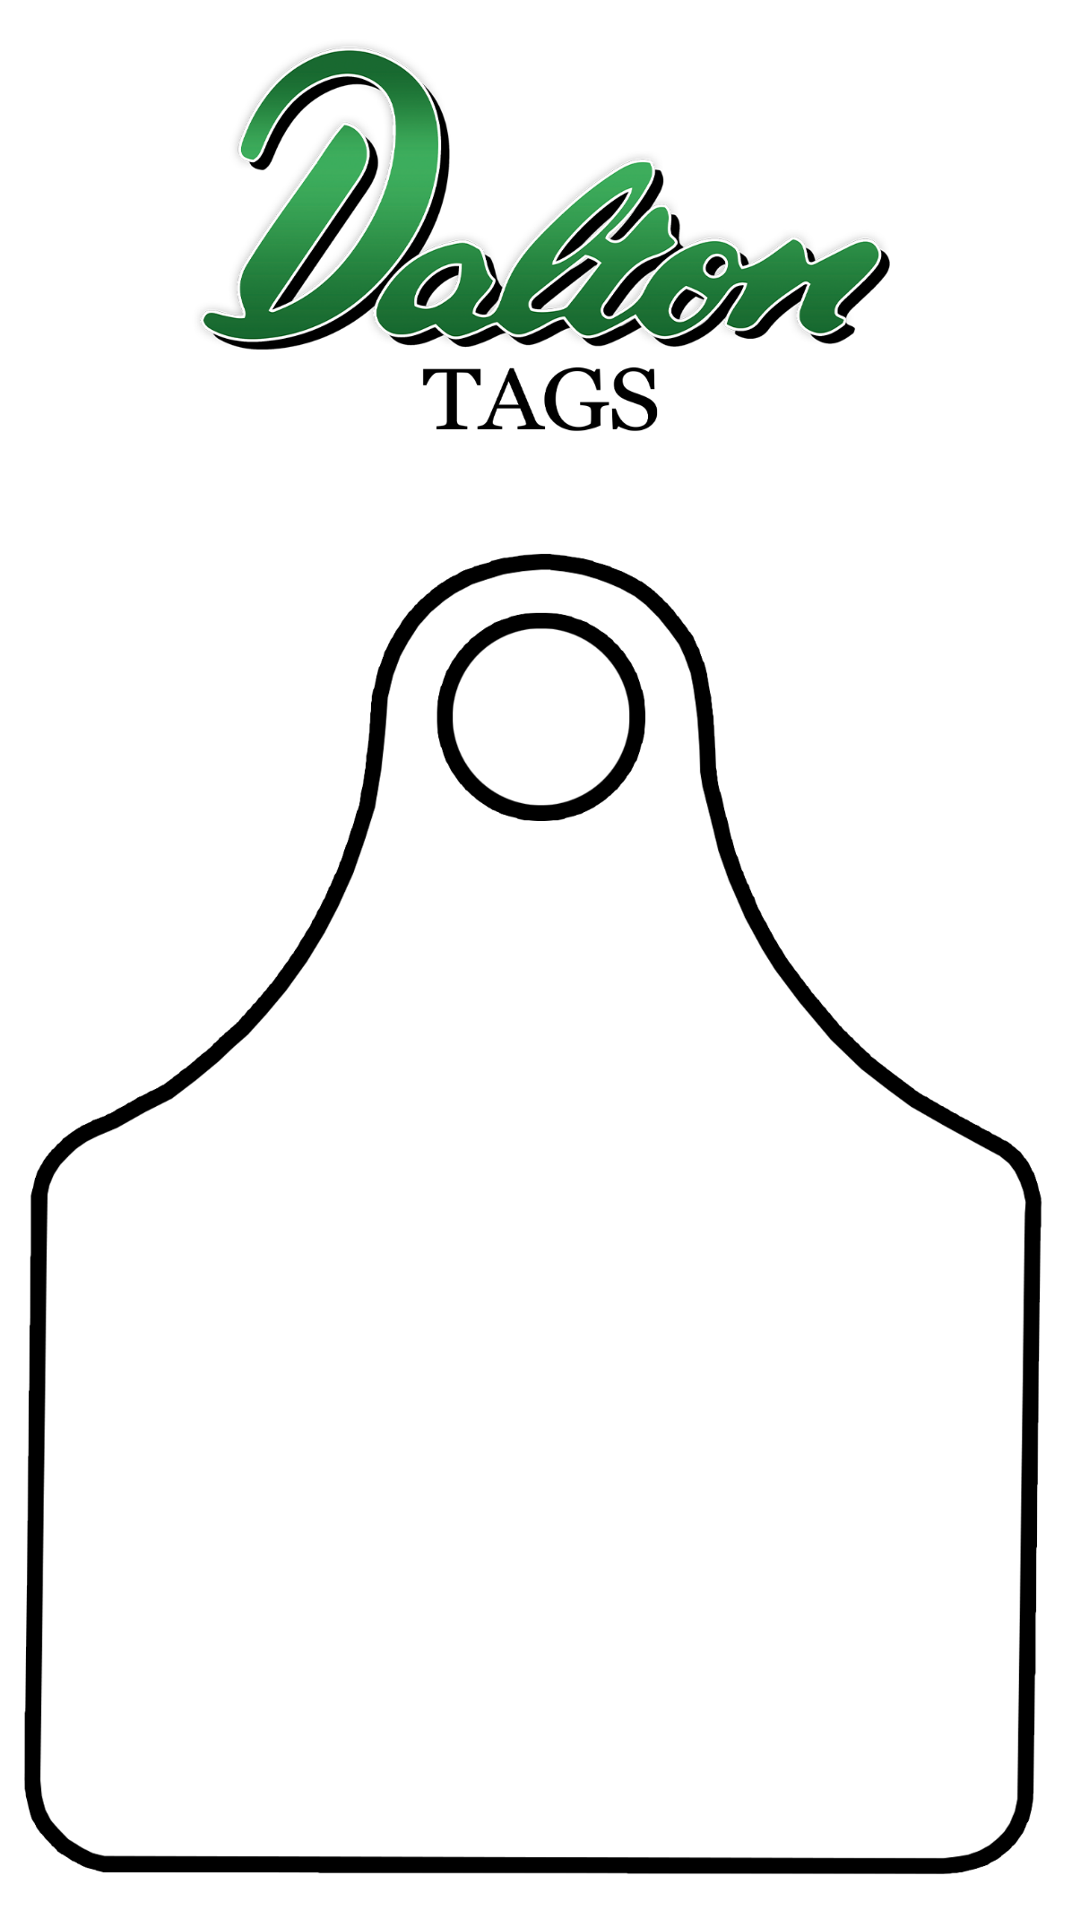
Design your own ear tag. Two winners will each receive their design on a personalised keyring and a bag of art goodies. Closing date is May 10th. Please post your entries on Dalton Tags social media (Facebook or Twitter), email to sales@daltontags.co.uk or post to Dalton Tags, Unit 3 Northern Road, Newark, Notts. NG24 2EU. Don’t forget to put your name, age and contact details. Under 16’s only. T & C’s apply. Good luck!

