Submission Form for: DALTON Pre-Paid Ear tissue samples for BVD virus testing

Sub Ref ………………..

Cross Ref ………………….

Date ………………….
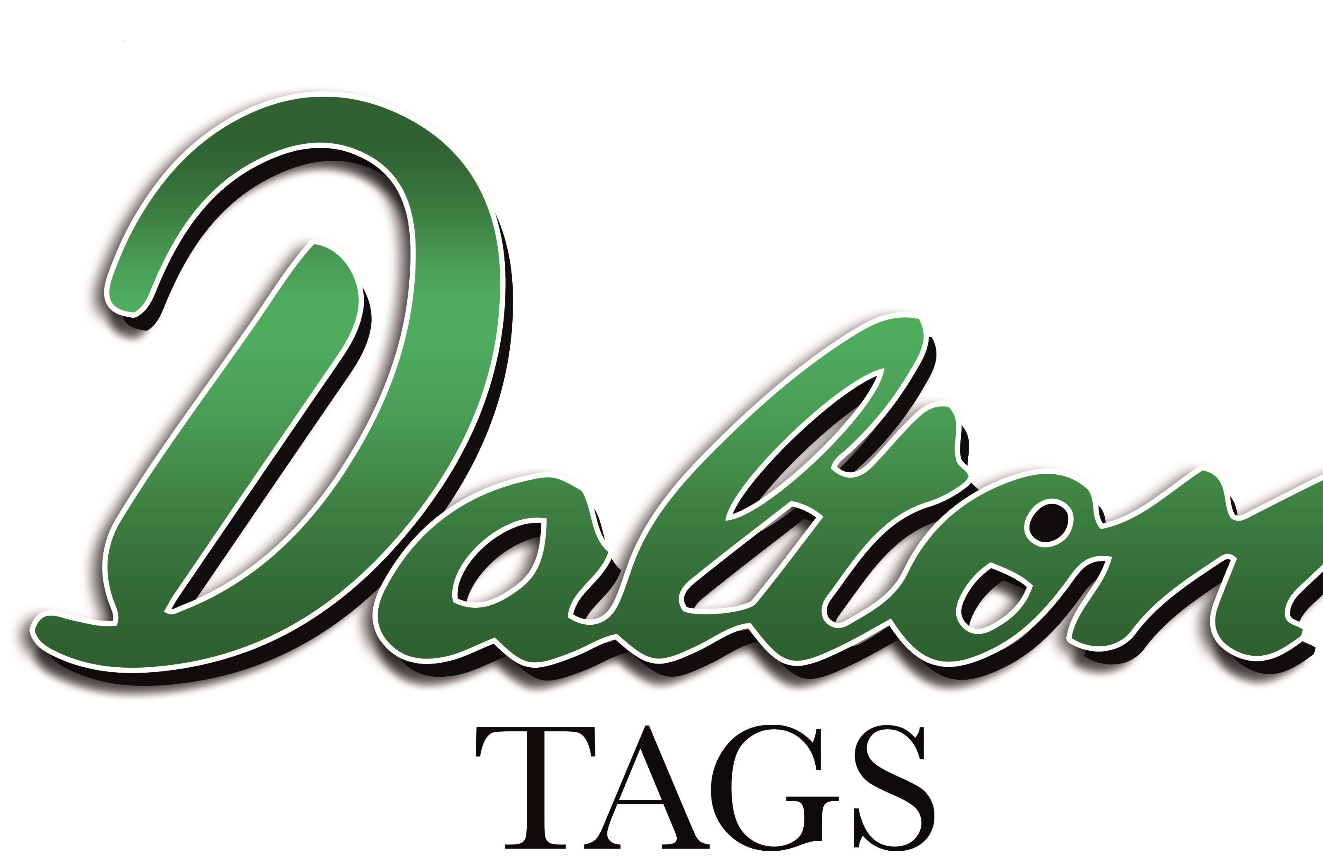
Send All Samples to:
SAC Veterinary Services, Greycrook,
St Boswells, Melrose, Roxburghshire, TD60EQ

If you are a Premium Cattle Health Scheme member please
Enter your PCHS member number ie SB/1234

To Be Completed In All Cases
Vet Practice |  | Herd Owner
Address |  | Holding Number
Address |  | Farm
Town |  | Address
Post code |  | Town
Email Address |  | Post Code
Practitioner |  | Email Address

Number of Ear Tissue Samples enclosed

THIS TEST COMPLETES THIS YEAR’S CALVING SAMPLES tick if true

PLEASE COMPLETE ANIMAL/TEST DETAILS OVERLEAF
(This is not required where tissue sample containers show the UK official tag number)

Comment:

Animal Identification, Sample Number and Test Required

 | Tag Nº | Ear Nº | Age/  DOB
1
2
3
4
5
6
7
8
9
10
11
12
13
14
15
16
17
18
19
20

